How to make accessible **presentations**   
with **Microsoft PowerPoint**

Microsoft PowerPoint is a presentation editor that can be found as part of office 365, a paid suite of applications from Microsoft. It includes a desktop application and web version and is compatible with most platforms including Windows and Mac.

The accessibility tips provided below work in both desktop and web versions of PowerPoint, however [some features may vary](https://support.microsoft.com/en-us/office/compare-powerpoint-features-on-different-platforms-90986850-227c-4b25-938e-1c5838166b8b) according to the version of PowerPoint that is being used and the operating system version. Many of the accessibility tips below are designed to make a presentation more navigable with a [screen reader](https://axesslab.com/what-is-a-screen-reader/).

# Make your slides **simple** and **easy-to-understand**

* 1. Consider your **target audience** and use [**plain language**](https://plainlanguagenetwork.org/plain-language/what-is-plain-language/) and **easy to understand** sentences as much as possible.
  2. Only put absolutely necessary information on each side. Consider **breaking text** onto separate slides – a good rule of thumb is to try and communicate **one concept per slide**.
  3. Whenever possible use [gender-neutral and inclusive language](https://www.un.org/en/gender-inclusive-language/guidelines.shtml)

Gender-neutral language is a generic term covering the use of non-sexist language, inclusive language or gender-fair language. The purpose of gender-neutral language is to avoid word choices which may be interpreted as biased, discriminatory or demeaning by implying that one sex or social gender is the norm. Using gender-fair and inclusive language also helps reduce gender stereotyping, promotes social change and contributes to achieving gender equality[1].

# Use **simple design** and **visuals** to communicate meaning.

* 1. A picture or video can be worth a thousand words. Pure text on slides can be difficult for some users to focus on and understand.
  2. If you are explaining complex ideas and concepts, **a visual reference** can be of help to readers in understanding your content.

# Make use of built-in **slide layouts**, **templates** and **themes**

* 1. Built-in slides, templates and themes should be your starting point for each presentation. Where possible **avoid copy-pasting text boxes** across slides.
  2. Be consistent with the templates, where possible use the ‘title’ box for your slide’s title, the ‘text’ space for your slide’s text, etc. This will ensure that screen readers can identify and read out loud the different elements of a slide.
  3. Use a **different title** on each slide, if possible: PowerPoint does not have a ‘table of contents’ function, but persons who are blind can use their screen reader to browse a presentation by the slide’s titles.

# Structure text using **built-in** **lists**

* 1. Make use of built in ‘numbered’ or ‘bulleted’ lists (instead of manually typing asterisks, points or hyphens) as they are recognized as lists and easily navigable with a screen reader.

# Consider **font size**, **type,** and **weight**

## Readable **font-size**

* + 1. Headings and points that are intended for presentation should be large enough for the target screen size.
    2. At minimum font-sizes should be at least 12 pt, but in most cases this will be too small; aim for at least 18 pt for the body of your content, 24 or 32 pt for headings, and over 48 pt for titles. This will aid legibility!

## Accessible **font-type**

* + 1. Where possible use sans-serif fonts like Arial, Calibri, or Verdana. Sans-serif fonts can be easier to read than decorative typefaces with serifs (such as Times New Roman, Garamond or Courier new) especially for persons with visual impairments or dyslexia. If a brand demands a specific font, check with the design team for which fonts options they have that are most accessible and readable.
       1. Where possible **avoid using proprietary fonts** as other users may not have the font on their system and your presentation may not look as intended to them. If the brand demands that you use a proprietary font, ensure it is legible and accessible. You may also be able to [**embed the font**](https://support.microsoft.com/en-us/office/embed-fonts-in-documents-or-presentations-cb3982aa-ea76-4323-b008-86670f222dbc#OfficeVersion=Windows)depending on your version of PowerPoint and whether you are on Windows or Mac.

## Accessible **font-weight**

* + 1. Some fonts have thin or heavy varieties that can be difficult to read, for example Calibri, which exists also as Calibri light. Aim to primarily use a regular font-weight for readability.

# Use appropriate **line** and **paragraph spacing**

* 1. Spacing can really improve the legibility of a presentation and help the user break the material into sections. Line spacing of ‘1.15’ and paragraph spacing of ‘6 pt’ before is ideal and can be applied through clicking on the home tab in the ribbon, choosing ‘Line Spacing Options’ and using the ‘paragraph pane’.

Screenshot of the ‘Paragraph’ panel in PowerPoint with paragraph and line spacing options

Figure 1 Screenshot of the ‘Paragraph’ panel in PowerPoint with paragraph and line spacing options

# Meaningful **hyperlinks**

* 1. Avoid using the entire web address as hyperlink text in the document as it is will be spoken out loud by the screen reader and it will be difficult to understand by a screen reader user.
  2. For hyperlinks use the text or word that best describes their purpose or content. For example, if you are including a link to a document, your hyperlink should appear as the name of the document. Always avoid using hyperlink descriptors like “click here” that do not describe the content of the link (especially problematic for persons using a screen reader or browsing through links via a keyboard).
  3. Also, check external links for accessibility before recommending them.

# **Images, charts,** and **graphics**

## Add **image descriptions** to essential images and charts.

* + 1. **Right click** on the Image or chart > select “Edit Alt text”.
    2. Enter an image description (short but meaningful).
    3. Image descriptions will be read-aloud by a screen reader helping users who have difficulty seeing the content.
    4. For tips on writing image descriptions refer to the [guidelines from the Diagram Center](http://diagramcenter.org/table-of-contents-2.html)

## Mark non-essential visual elements as **decorative.**

* + 1. Right click on any visual element > click “Edit Alt Text” > Check the box “Mark as decorative”.
    2. Why? This means that a screen reader will completely ignore this non-essential visual element, which will make the document much more navigable.  
         
       Screenshot of Alt Text panel in PowerPoint with the 'mark as decorative' option highlighted

Figure 2 Screenshot of Alt Text panel in PowerPoint with the 'mark as decorative' option highlighted

# Use the **selection pane** to re-order content in **logical reading order**

* + 1. The logical reading order of the elements of a slide is not the visual order of the elements, but the order in which elements will be read by a screen reader. A slide with a perfectly logical *visual* order might not be as logical in terms of *reading* order!
    2. Click on order > selection.
    3. Order items in **REVERSE** order (bottom to top). That means the title should be at the bottom of the list, and the top of the list should be the LAST ITEM you intend to be read by a screen reader.

Screenshot of the PowerPoint selection pane for selecting the object's order

Figure 3 Screenshot of the PowerPoint selection pane for selecting the object's order=

# Ensure color **contrast** between text and background

* 1. The PPT accessibility checker will help you by displaying a warning if the contrast between the color of your text and the color of your background does not meet the requirements for persons with visual impairments; your target contrast should be a 3:1 ratio.
  2. You can use this app: [Color Contrast Analyzer](https://go.microsoft.com/fwlink/p/?linkid=256505) to help you.
  3. You can also use **high-contrast** color schemes to ensure your layout always meets contrast requirements.

# Do not rely only on **color** to communicate meaning

* 1. Color should be used sparingly as a design element to help guide the reader. Color should not be used as the only way to provide an information, because this would be missed by color blind persons.
  2. Symbols and/or patterns used together with color can make a graph or a diagram more accessible by helping users who cannot differentiate color.

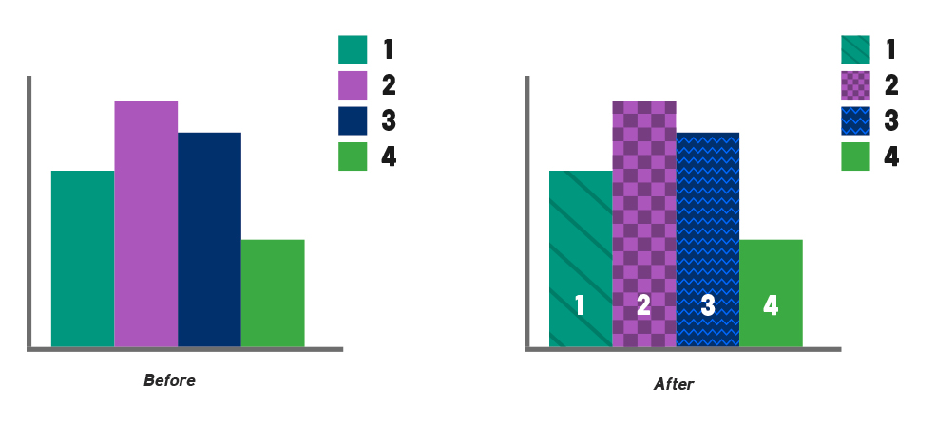

Figure 4 Difference between an infographic based only on color and one which uses also patterns and lettering

# Use the built-in **accessibility checker**

* 1. Go to “Review” > “Check Accessibility” and follow the on-screen prompts.

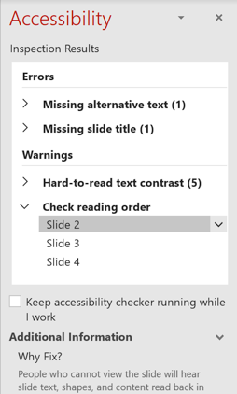

Figure 5 Screenshot of the PowerPoint Accessibility panel which shows accessibility warnings and suggestion.

# Make your live presentation **inclusive**

## Use the **auto-captioning tool** when presenting

* + 1. Check [your version of PowerPoint](https://support.microsoft.com/en-us/office/present-with-real-time-automatic-captions-or-subtitles-in-powerpoint-68d20e49-aec3-456a-939d-34a79e8ddd5f#OfficeVersion=Windows) to see if this feature is available.
    2. Slideshow > Check “Always use subtitles”.
    3. Every word you speak will be displayed on screen for all viewers of the presentation as a caption.

# Provide a **copy of your accessible slides** before the live presentation for **download**

* 1. This can be essential for blind and low vision users but can help all viewers familiarize themselves with your content.

**Additional Links**

Read more about ways to make your PowerPoints accessible

* <https://webaim.org/techniques/powerpoint/>
* <https://support.microsoft.com/en-us/office/make-your-powerpoint-presentations-accessible-to-people-with-disabilities-6f7772b2-2f33-4bd2-8ca7-dae3b2b3ef25>
* <https://www.washington.edu/accessibility/documents/creating-accessible-presentations-in-microsoft-powerpoint/>
* [Microsoft PPPT accessibility guide](https://support.microsoft.com/en-us/topic/make-your-powerpoint-presentations-accessible-to-people-with-disabilities-6f7772b2-2f33-4bd2-8ca7-dae3b2b3ef25)
* [10 principles for accessibility of presentations from Perkins International](https://www.perkinselearning.org/technology/blog/how-create-accessible-powerpoints).

1. [GNL_Guidelines_EN.pdf (europa.eu)](https://www.europarl.europa.eu/cmsdata/151780/GNL_Guidelines_EN.pdf)